EOC STRONG BOOTCAMP ANSWERSHEET
NAME:
IN -CLASS PRACTICE  - COMPLETE ALL SIX  - REQUIRED  - TEST GRADE | TUTORIAL PRACTICE  - COMPLETE THREE  - OPTIONAL  - QUIZ GRADE
WEEK 1 PRACTRICE | WEEK 1 EXTRA PRACTICE
HOW DO I FEEL?  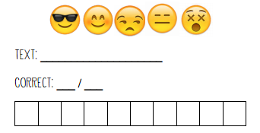 | HOW DO I FEEL?
WEEK 2 PRACTICE | WEEK 2 EXTRA PRACTICE
HOW DO I FEEL? | HOW DO I FEEL?
WEEK 3 PRACTICE | WEEK 3 EXTRA PRACTICE
HOW DO I FEEL? | HOW DO I FEEL?
WEEK 4 PRACTICE | WEEK 4 EXTRA PRACTICE
HOW DO I FEEL? | HOW DO I FEEL?

WEEK 6 PRACTICE | WEEK 6 EXTRA PRACTICE
HOW DO I FEEL? | HOW DO I FEEL?
WEEK 6 PRACTICE | WEEK 6 EXTRA PRACTICE
HOW DO I FEEL? | HOW DO I FEEL?

CONSTRUCTED RESPONSE
DIRECTIONS: FOR EACH PASSAGE A CONSTRUCTED RESPONSE QUESTION HAS BEEN PROVIDED. ON A SEPARATE SHEET OF PAPER, WRITE A PARAGRAPH ANSWER TO THE QUESTION USING APE FORMAT. PROVIDED BELOW IS A TEMPLATE FOR HOW TO ANSWER A CR AS WELL AS A GENERIC RUBRIC THAT WILL BE USED TO ASSIGN A GRADE TO THEM.
MAKE SURE TO:
- BREAK DOWN THE QUESTION
- USE APE FORMAT
- NUMBER THE QUESTION ON YOUR SEPARATE SHEET OF PAPER
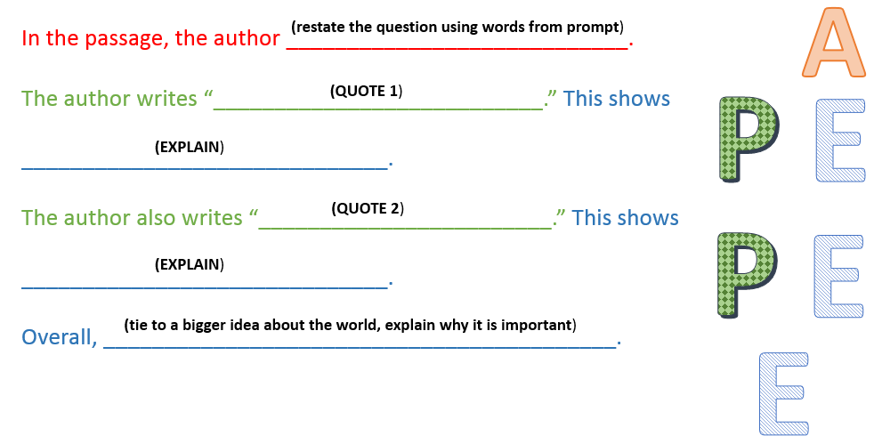
- KEEP YOUR RESPONSES COLLECTED IN YOUR FOLDER

