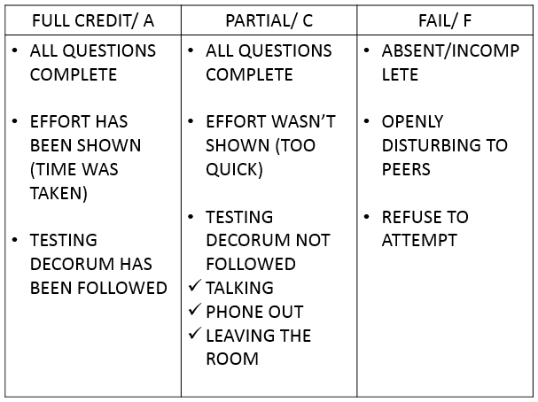

EOC

STRONG

**GET IN FORMATION**

1. Read the passage CAREFULLY. Highlight key ideas, things that stand out to you. OPTION: at the end of each paragraph write down the main idea

2. Use your strategies to answer the MC questions:

#1.

#2.

#3.

#4.

#5.

#6.

#7.

3. If there’s a CR, go through your process & use APES.

4. Actually try (I know, right) and REMEMBER TO BREATHE.

**KNOW THE ENEMY**

* ____ MINUTES
* ____ MULTIPLE CHOICE
* ____ PERCENT OF GRADE
* ____ DIFFERENT TEXTS
* ____ CONSTRUCTED RESPONSE PARAGRAPHS
* ____ TEST TO CONQUER

**EOC STRONG: THE PLAN**

* We will read different PASSAGES every week, focusing on a new genre each time.
* You MUST read and use TEST STRATEGIES.
* When you finish, check you work AND REMAIN QUIET WITH NO PHONE. Remember, we are practicing endurance and getting in the right mindset; this starts with the right conditions.
* If you do the passages to the best of your ability, you will get full credit. YOU MUST have answers done before we go over them, and you must show that you’ve used your strategies.
* If you’re ABSENT, you must make it up.
* These passages will add up to a TEST GRADE.
* If you do what you should, you’ll be prepared for the EOC and have an easy test grade ☺

**BOOTCAMP PHILOSOPHY**

* Physical **______________** & Stamina
* Correct **______________** & Mental Aerobics
* All about **_______________** of skills
* **_______________** to get better and improve
* Important job: **_______________** your grade
* Show off your **_______________,**